Design
Project: NoteNecklace
STA-EN06-Group 01
Class: STA-OIL470-CMK

1. Introduction
This document describes the frontend design contribution for the NoteNecklace project. The overall project focuses on creating a smart device and supporting application for recording and transcribing conversations, while this document specifically covers the user interface, user experience, and visual design of the web application.
My responsibility within the group is the design and implementation of the frontend, including layout structure, visual styling, animations, and interaction feedback. The aim of the frontend is to present complex functionality in a clear, accessible, and user-friendly way, allowing users to focus on recording and reviewing notes rather than managing technical details.
This frontend was developed to support the broader system, which includes backend logic and device functionality handled by other group members.

2. User Interaction Flow (Frontend Perspective)
From a frontend perspective, the user flow focuses on how users navigate and interact with the interface rather than backend processes.
The user begins on the Dashboard, where the primary action is starting and stopping recordings. Visual feedback clearly indicates recording, processing, and completion states.
From the navigation, users can access:
- Dashboard – main interaction for recording and viewing recent notes
- My Account – profile information, device overview, and access to settings
- Settings – appearance options, device status, and data management
- About – explanation of how NoteNecklace works and its key features
The flow is designed to remain simple and predictable, with consistent layouts and navigation patterns across all pages.

3. Design Wireframes
Before development, wireframes were created in Figma to define the structure of each frontend page. These wireframes focused on:
- visual hierarchy for primary actions
- card-based content organization
- consistent spacing and alignment
- clear navigation between sections
The wireframes acted as a blueprint for the frontend implementation and helped reduce design changes during development.

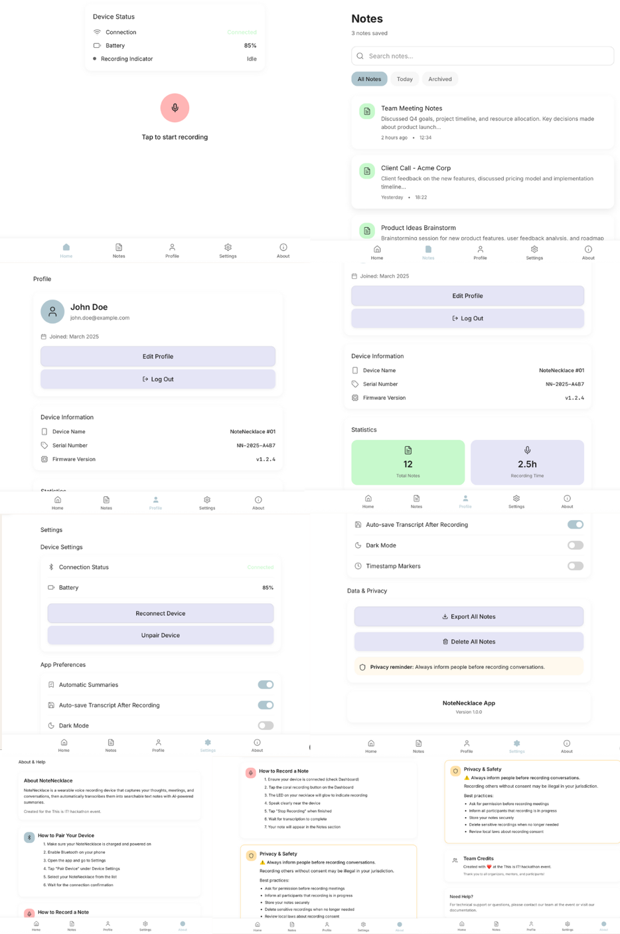

4. Design Statement

Color Palette
The frontend uses a peach and coral accent palette, supported by neutral stone and white tones. These colors were chosen to create a warm and approachable interface that aligns with a wearable, personal device.
Accent colors are reserved for:
- primary actions (record button)
- important highlights and badges
- active and hover states

Typography
A clean sans-serif font is used throughout the interface to ensure readability and consistency across pages. Font size and weight are used to establish hierarchy rather than excessive color changes.

Layout
The frontend layout follows a card-based design with rounded corners and generous spacing. This improves clarity, separates content logically, and creates a modern, calm visual appearance.

Visual Feedback
Animations and transitions are implemented using Framer Motion to provide feedback for:
- recording and processing states
- hover and active interactions
- modal transitions
These effects help users understand system status without being distracting.

5. Frontend Proof of Concept

Implementation
- Developed using React with reusable components
- Styled with Tailwind CSS using a shared design system
- Used Framer Motion for animations and transitions
- Implemented responsive layouts for desktop and tablet screens
- Integrated consistent iconography using Lucide Icons
- Matched the frontend closely to high-fidelity Figma designs

Testing
- Manual testing of all frontend navigation paths
- Visual comparison between Figma designs and implementation
- Interaction testing for buttons, animations, and modals
- Peer feedback used to improve spacing, contrast, and usability

6. Frontend Design Choices

Layout & Navigation
The dashboard design prioritizes the recording action as the most important interaction. Secondary information, such as recent notes and device status, is placed around the primary action without competing for attention.
Navigation is kept minimal and consistent to reduce confusion. Advanced options are placed under My Account to keep daily usage simple.

Color & Visual Identity
- Warm accent colors create approachability
Peach and coral make the interface feel personal rather than technical.
- Limited accent usage improves focus
Using color only where necessary ensures important actions stand out.
- Neutral backgrounds reduce cognitive load
Soft backgrounds help users focus on content and interactions.
- Consistent gradients strengthen visual identity
Reusing gradients across pages creates a cohesive frontend experience.

7. Frontend Scope & Limitations
This design document covers only the frontend layer of the project. Backend logic, data persistence, authentication, and device communication are outside the scope of this document and handled by other team members.
Current limitations of the frontend prototype include:
- placeholder data instead of live backend data
- simulated device status and recording states
- no persistent user preferences
These limitations are acceptable at this stage and allow focus on validating the frontend design and user experience.

